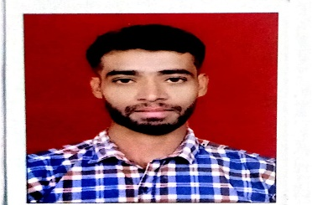
Nabisha
Photo
Sri Ram Pg, 3rd Cross, Kundalahalli Colony, near AECS layout,
Kundalahalli Gate,Karnataka-560037
Email ID: nash22ece@cmrit.ac.in/nabim1077@gmail.com
Mobile No: +91 6361661208
LinkedIn: https://www.linkedin.com/in/nabisha-shakhil-ahamad-7596a6309
CAREER OBJECTIVE
Utilize my knowledge of electronics and communication systems in a dynamic role that allows me to contribute to cutting-edge technologies while enhancing my technical skills and professional growth
EDUCATION QUALIFICATION
- Bachelor of Engineering – Computer science Engineering
CMRIT, AECS Layout, Bangalore
7.3, 2025
- Diploma
Govt Polytechnic Kalaburagi
75.80%, 2023
- 10th
Govt High School, Tengli
79.68%, 2020
TECHNICAL SKILLS
Languages: Python, C++, Verilog(Basics)
Frameworks: HTML, CSS, JavaScript, System Verilog
Software: Matlab, Solid edge , Multisim, u-vision Keil
Database: MySQL
PROJECTS
- Title: Diabetes prediction System
Description: Analyzes health data to assess an individual's risk of diabetes using machine learning algorithms. It supports early diagnosis and preventive care
Tech Stack: : HTML, CSS, Python
Tool Use: VS Code, Jupyter notebook
- Title: Microcontroller-Based Tachometer
Description: A Microcontroller-Based Tachometer measures the rotational speed (RPM) of an object using sensors like optical encoders or Hall effect sensors.
Tech Stack: d Microcontroller, display, Speed sensor, power supply
Tool Use: Arduino IDE, MPLAB X IDE, Atmel Studio
INTERNSHIPS
- Company Name: Utilinet Software Solutions
- Duration: 4 months
- Designation: Intern
- Responsibilities: Quality Manage

CO-CURRICULAR & EXTRA CURRICULAR ACTIVITIES
- Online Courses & Certifications: Python Complete Course And Flask Frame Work ,Full stack development course
- NSS : Social connectivity and responsibility
PERSONAL DETAILS
Date of Birth : 15/05/2003
Gender : male
Nationality : Indian
Permanent Address : Kalaburagi, Chittapur, Tengli, Karnataka-585317
Linguistic Competency : Kannada, English, Hindi
Hobbies : Volleyball, Cricket

